**Experiment No.1**

Aim:- Case Study on Matomo

**Theory:**

# Introduction

Matomo, formerly known as Piwik, is an open-source web analytics platform that provides detailed reports on website visitors, search engines and keywords used, language, and more. [It’s designed to respect the privacy of users while giving valuable insights to website](https://matomo.org/case-studies/) [owners](https://matomo.org/case-studies/)1.

# Development Details

Matomo was created to be an alternative to Google Analytics, focusing on user privacy and data ownership. The platform is built using PHP and MySQL, and it’s easily extensible with plugins.

# Features

* + Privacy-focused: Matomo offers enhanced privacy features, including cookieless tracking and full data ownership.
  + Customizable Dashboard: Users can create and customize their own dashboards with widgets to focus on the metrics that matter most to them.
  + E-commerce Tracking: Matomo provides detailed e-commerce tracking, allowing users to track sales, cart abandonment, and product performance.

# How to Use

To use Matomo, you need to install it on your server, add a tracking code to your website, and configure your dashboard. Matomo also offers cloud hosting for those who prefer not to self- host.

# Applications (Who Can Use It)

Matomo is suitable for businesses of all sizes, non-profits, government institutions, and personal websites. It’s particularly beneficial for those who prioritize user privacy and data ownership.

# Few Screenshots

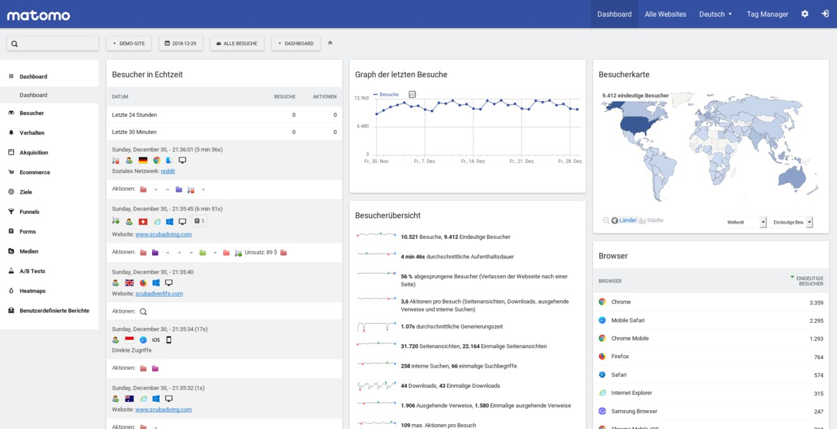

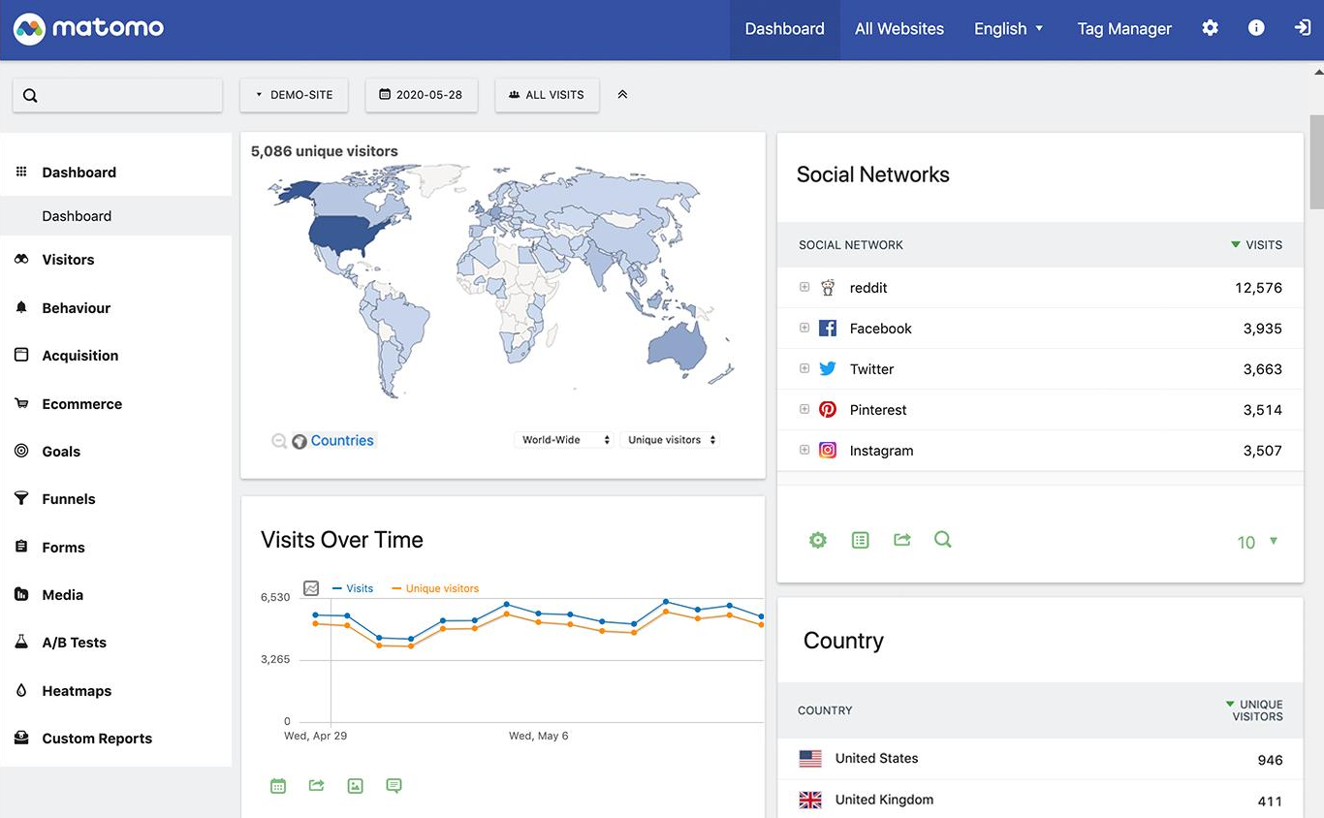

* **Conclusion**

Matomo stands out as a powerful analytics tool that respects user privacy and offers comprehensive features for website analysis. [Its flexibility and commitment to ethical data](https://matomo.org/case-studies/) [practices make it a strong choice for anyone looking to move away from traditional analytics](https://matomo.org/case-studies/) [solutions](https://matomo.org/case-studies/)